Midterm Quiz 2 due Nov 15, 2021 02:00 EST

Completed

**90 Minute Time Limit**

**Instructions**

* **Work alone.** Do not collaborate with or copy from anyone else.
* Work the problems in any order you wish, but submit each answer before ending the exam.
* You may use any of the following resources:
  + One sheet (both sides) of handwritten (not photocopied or scanned) notes
* If any question seems ambiguous, use the most reasonable interpretation (i.e. don't be like Calvin):  
    
  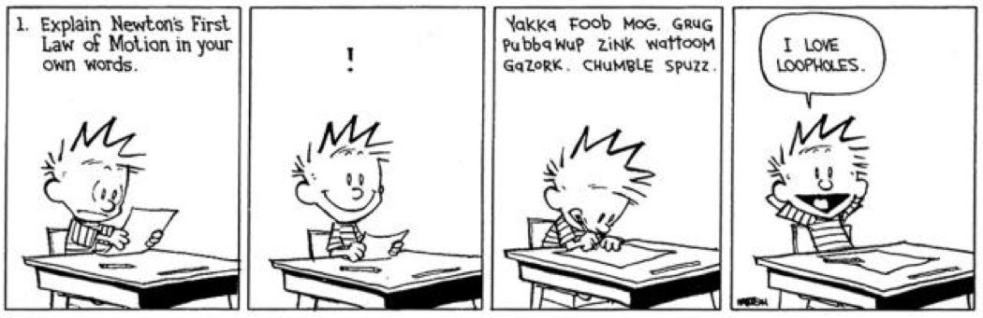
* **If you experience any technical issues (i.e. Math Processing Error), please save your current selected answers and refresh the page. If the issue persists, then please finish the exam and let the Instructors know about the issue in a private Piazza post afterwards.**
* Good Luck!

**This is the beginning of Midterm Quiz 2. Please make sure that you submit all your answers before the time runs out. Once you submit an answer to a question, you cannot change it. There is no overall Submit button.**

**After submitting all answers, please click the "End my Exam" button, above, before exiting from ProctorTrack to complete your exam.**

